# [LAW & ORDER: ORGANIZED CRIME: Brent Antonello Previews Jamie’s Undercover Gig as a Getaway Driver](https://www.givememyremote.com/remote/2023/01/03/law-order-organized-crime-jamie-undercover-brent-antonello-interview/)

January 3, 2023 by [Marisa Roffman](https://www.givememyremote.com/remote/author/marisa/)

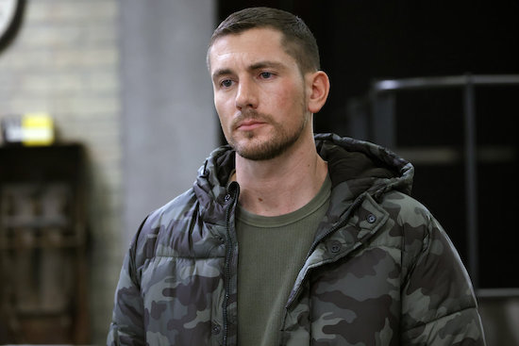

***LAW & ORDER: ORGANIZED CRIME — “Trap” Episode 310 — Pictured: Brent Antonello as Det. Jamie Whelan — (Photo by: Will Hart/NBC)***

LAW & ORDER: ORGANIZED CRIME kicks off 2023 with a new team member going undercover in the Thursday, January 5 episode, “Trap”: Jamie ([Brent Antonello](https://www.givememyremote.com/remote/2022/07/29/law-and-order-organized-crime-season-3-cast-rick-gonzalez-brent-antonello-nona-parker-johnson/))!

“We find out that Stabler has an informant whose wife was kidnapped by a gang based out of Miami, and they want to expand their enterprise in New York,” Antonello previews to [Give Me My Remote](https://www.givememyremote.com/remote/). “They recruit getaway drivers from street racing, so they hire the best of the best. But then we find out that Jamie has a background with stock car racing. Fortunately, Bell and Stabler allow him to do a deep-dive and go undercover and see what happens.”

For Antonello, he first heard whispers of Jamie’s background from the crew. “[They] usually get the scripts before us—the department heads—and then people [were] coming up to me two episodes before we shot this like, ‘Dude, this is a fun one coming up. It’s like a FAST AND THE FURIOUS thing…you’re a driver,'” he recalls.

When he read it himself, “I called [Sean [Jablonski]](https://www.givememyremote.com/remote/2022/09/01/law-and-order-organized-crime-showrunner-sean-jablonski-bryan-goluboff-exits/), our showrunner, and was like, ‘Dude, this is awesome,'” Antonello shares. “He was like, ‘Yeah, have fun!’…I think we can keep this background [information in play] for future episodes, hopefully. It’s been fun.”

Though viewers will get to see Jamie behind the wheel in the arc, Antonello shares he “unfortunately” wasn’t able to do any of his own stunts for any of the more specialized car scenes.

“It wouldn’t look as good if I did, because there would be awkward movements and the car just wouldn’t have that sexy car appeal,” he says with a laugh. “But I guess I did well on the LED stage, which is when [we’re filming scenes inside the car and] the car’s not even moving. But I saw [some of the stunts being] finished at like one o’clock in the morning, the day that they had their second unit, and I saw some stuff [viewers will see in the episode]—they’re so good at what they do.”

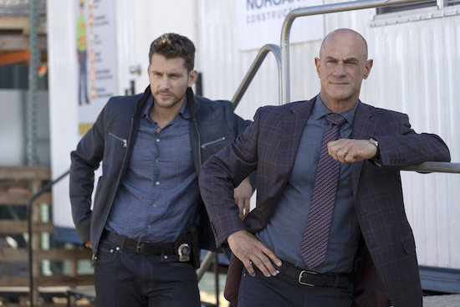

***LAW & ORDER: ORGANIZED CRIME — “Everybody Knows the Dice are Loaded” Episode 302 — Pictured: (l-r) Brent Antonello as Detective Jamie Whelan, Christopher Meloni as Detective Elliot Stabler — (Photo by: Eric Liebowitz/NBC)***

As Jamie embarks on his first undercover case with the unit, it also serves to highlight some of the similarities between the detective and his quasi-mentor, Elliot Stabler ([Christopher Meloni](https://www.givememyremote.com/remote/2021/06/04/svu-organized-crime-benson-stabler-romance-mariska-hargitay-christopher-meloni/)).

But with Stabler going through his own troubles in the hour, how is Jamie balancing looking to his colleague for inspiration versus looking at pitfalls to avoid? “I don’t even think there’s a little bit of, ‘I want to avoid it,'” Antonello admits. “I think Jamie is all in, and he sees [that Stabler] was a wild card back in the day. [Their mindset is] do everything you can to bring this person to justice, and do it the right way.”

“There’s really this fine gray area that they dabble with, which is fun to play, especially seeing Chris do it,” he continues. “And he looks up to him. I wouldn’t say a father figure, but he’s like a head coach, if you will. [Jamie thinks,] ‘If he did it this way, I can do it this way, and I’m not gonna get in trouble for it, because he did that way.’ That’s the way he is.”

Which puts Elliot—and Bell ([Danielle Moné Truitt](https://www.givememyremote.com/remote/2022/12/08/law-order-organized-crime-task-force-saved-danielle-mone-truitt-interview/)), who is in charge of *both* of them—in a tough spot at times. “You see Stabler, in that same way, battling his intentions, because he sees [Jamie’s actions] and he thinks the same thing: I did this way, so I can’t really get mad at him. But I can reel him in a little bit,'” Antonello previews. “And I think that’s the conflict that Bell and Stabler have, which is cool. So there’s definitely those little tug of war moments of, ‘Is he doing the right thing? He’s not, but we’re getting closer to closing the case.’ Which is fun.”

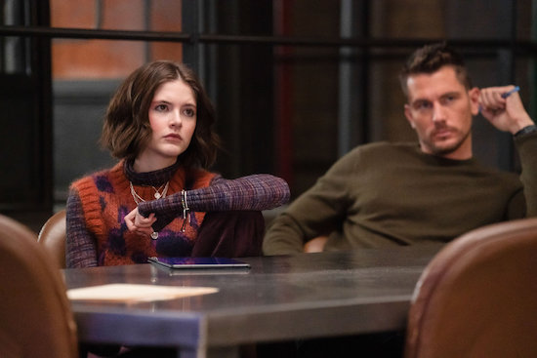

***LAW & ORDER: ORGANIZED CRIME — “All That Glitters” Episode 307 — Pictured: (l-r) Ainsley Seiger as Det. Jet Slootmaekers, Brent Antonello as Det. Jamie Whelan — (Photo by: Ralph Bavaro/NBC)***

Also complicated, in a different way, for Jamie? His relationship with Jet (Ainsley Seiger). The duo have worked together a number of times this season, with the normally reclusive Jet actually opening up to Jamie (a little) about her past. But is there something more there?

“Jamie just sees her as someone who he hasn’t really come across before,” Antonello explains. “Because Jamie is more of the outgoing, charismatic, doesn’t really care about what others think [kind of guy], coming across Jet, especially reading the first scene that we had with each other—Jet doesn’t really look at Jamie, she’s in her own world, and he’s kind of intrigued by it. And I think he really tried to get in, to [get her to] open the door in that club scene in the first episode [together].”

“Jamie sees that and likes to mess around with Jet a little bit,” he continues. “Even if he sees her as the younger sister, he likes to push her buttons a little bit, to see how far you can actually go. But at the same time there’s this chemistry between them that you can’t really identify yet. Which is fun, because there’s that, again, gray area, and you could go either way with it. The writers like to play with [it], as well. I think down the line we’ll get an answer. But right now we’re really, really on that tightrope of which way it could go.”

***LAW & ORDER: ORGANIZED CRIME, Thursdays, 10/9c, NBC***

**RELATED:**

* [LAW & ORDER: ORGANIZED CRIME: ‘Trap’ Photos](https://www.givememyremote.com/remote/2022/12/30/law-order-organized-crime-trap-photos/)
* [LAW & ORDER: ORGANIZED CRIME’s Danielle Moné Truitt: The Task Force Being Ambushed Requires Them to ‘Put Their Differences Aside’ to Survive](https://www.givememyremote.com/remote/2022/12/07/law-and-order-organized-crime-danielle-mone-truitt-last-christmas-preview/)
* [LAW & ORDER: ORGANIZED CRIME: ‘Last Christmas’ Photos](https://www.givememyremote.com/remote/2022/12/05/law-order-organized-crime-last-christmas-photos/)
* [LAW & ORDER: ORGANIZED CRIME: ‘Whipping Post’ Photos](https://www.givememyremote.com/remote/2022/11/14/law-order-organized-crime-whipping-post-photos/)
* [LAW & ORDER: ORGANIZED CRIME Composer Ruth Barrett on Crafting the Show’s Score and the Just-Released Season 1 Soundtrack](https://www.givememyremote.com/remote/2022/11/09/law-and-order-organized-crime-season-1-soundtrack-ruth-barrett-interview/)
* [LAW & ORDER: ORGANIZED CRIME: ‘All That Glitters’ Photos](https://www.givememyremote.com/remote/2022/11/07/law-order-organized-crime-all-that-glitters-photos/)
* [LAW & ORDER: ORGANIZED CRIME: ‘Blaze of Glory’ Photos](https://www.givememyremote.com/remote/2022/10/28/law-order-organized-crime-blaze-of-glory-photos/)
* [LAW & ORDER: ORGANIZED CRIME Post-Mortem: Rick Gonzalez on the Reyes Twist: ‘This is Bobby’s Moment’](https://www.givememyremote.com/remote/2022/10/27/law-and-order-organized-crime-reyes-brothers-rick-gonzalez-interview/)
* [LAW & ORDER: ORGANIZED CRIME: Rick Gonzalez Previews a Case ‘Intimately Connected’ to Reyes](https://www.givememyremote.com/remote/2022/10/25/law-and-order-organized-crime-rick-gonzalez-interview/)
* [LAW & ORDER: ORGANIZED CRIME: ‘Behind Blue Eyes’ Photos](https://www.givememyremote.com/remote/2022/10/20/law-order-organized-crime-behind-blue-eyes-photos/)
* [Kelli Giddish’s Final LAW & ORDER: SPECIAL VICTIMS UNIT Episode Set for December](https://www.givememyremote.com/remote/2022/10/11/law-and-order-svu-rollins-final-episode-kelli-giddish/)
* [LAW & ORDER: ORGANIZED CRIME: ‘Spirit In The Sky’ Photos](https://www.givememyremote.com/remote/2022/10/07/law-order-organized-crime-spirit-in-the-sky-photos/)
* [LAW & ORDER: ORGANIZED CRIME: ‘Catch Me If You Can’ Photos](https://www.givememyremote.com/remote/2022/09/30/law-order-organized-crime-catch-me-if-you-can-photos/)
* [NBC Releases New Key Art for LAW & ORDER, SVU, and ORGANIZED CRIME](https://www.givememyremote.com/remote/2022/09/26/key-art-law-order-svu-organized-crime/)
* [LAW & ORDER: ORGANIZED CRIME: ‘Everybody Knows the Dice are Loaded’ Photos](https://www.givememyremote.com/remote/2022/09/23/law-order-organized-crime-everybody-knows-the-dice-are-loaded-photos/)
* [LAW & ORDER: ORGANIZED CRIME Season 3 Will Become ‘Politically Dangerous’ for Bell](https://www.givememyremote.com/remote/2022/09/23/law-and-order-organized-crime-bell-season-3/)
* [LAW & ORDER Crossover Co-Writer Gwen Sigan Shares Her Favorite ‘Gimme Shelter’ Scenes](https://www.givememyremote.com/remote/2022/09/23/law-and-order-gimme-shelter-best-scenes-gwen-sigan/)
* [LAW & ORDER Crossover Event Recap: ‘Gimme Shelter’ Sets Up a Big SVU Storyline](https://www.givememyremote.com/remote/2022/09/22/law-and-order-crossover-recap-rollins-shot/)
* [LAW & ORDER: ORGANIZED CRIME: What You Need to Know About the Season Premiere](https://www.givememyremote.com/remote/2022/09/22/law-and-order-organized-crime-season-3-premiere/)
* [LAW & ORDER Crossover Event: ‘Gimme Shelter’ Photos](https://www.givememyremote.com/remote/2022/09/20/law-order-crossover-event-gimme-shelter-photos/)
* [LAW & ORDER’s Rick Eid on Co-Writing ‘Gimme Shelter’: ‘We Threw Format Out the Window’ for the Franchise-First Crossover](https://www.givememyremote.com/remote/2022/09/20/law-and-order-crossover-writer-rick-eid/)
* [LAW & ORDER Crossover: Watch the Action-Packed First Footage From ‘Gimme Shelter’](https://www.givememyremote.com/remote/2022/09/08/law-order-crossover-promo-gimme-shelter-video/)
* [LAW & ORDER: ORGANIZED CRIME Adds Janel Moloney](https://www.givememyremote.com/remote/2022/09/06/law-and-order-organized-crime-seaon-3-cast-janel-moloney/)
* [LAW & ORDER: ORGANIZED CRIME: Bryan Goluboff Exits, Sean Jablonski to Serve as Showrunner](https://www.givememyremote.com/remote/2022/09/01/law-and-order-organized-crime-showrunner-sean-jablonski-bryan-goluboff-exits/)
* [NBC Reveals LAW & ORDER Crossover Key Art](https://www.givememyremote.com/remote/2022/09/01/law-and-order-crossover-poster/)
* [Bryan Goluboff Teases How LAW & ORDER: ORGANIZED CRIME and SVU Will Dive Into Elliot and Olivia’s Time Apart—and Previews Their Future](https://www.givememyremote.com/remote/2022/08/29/organized-crime-elliot-olivia-relationship-svu-bryan-goluboff/)
* [LAW & ORDER: ORGANIZED CRIME is Shaking Up Its Format in Season 3](https://www.givememyremote.com/remote/2022/08/24/law-and-order-organized-crime-season-3-spoilers-bryan-goluboff/)
* [Behind-the-Scenes Photos and Videos from the LAW & ORDER Franchise Crossover](https://www.givememyremote.com/remote/2022/08/24/behind-the-scenes-photos-and-videos-from-the-law-order-franchise-crossover/)
* [NBC Confirms LAW & ORDER Crossover Event With New Promo](https://www.givememyremote.com/remote/2022/08/24/law-and-order-svu-organized-crime-crossover-event/)
* [LAW & ORDER: ORGANIZED CRIME Adds Gus Halper and Camilla Belle](https://www.givememyremote.com/remote/2022/08/12/law-order-organized-crime-gus-halper-camilla-belle/)
* [LAW & ORDER: ORGANIZED CRIME Adds Rick Gonzalez and Brent Antonello](https://www.givememyremote.com/remote/2022/07/29/law-and-order-organized-crime-season-3-cast-rick-gonzalez-brent-antonello-nona-parker-johnson/)
* [6 Dream LAW & ORDER Franchise Crossover Pairings](https://www.givememyremote.com/remote/2022/07/14/6-dream-law-and-order-franchise-crossover-pairings/)
* [NBC Eyes LAW & ORDER-SVU-ORGANIZED CRIME Crossover Event](https://www.givememyremote.com/remote/2022/07/06/law-and-order-cross-ver-svu-organized-crime-nbc/)
* [LAW & ORDER: ORGANIZED CRIME Sets Bryan Goluboff as Showrunner](https://www.givememyremote.com/remote/2022/05/26/law-and-order-organized-crime-season-3-showrunner-bryan-goluboff/)
* [LAW & ORDER: ORGANIZED CRIME Season 2 Finale Recap: Elliot’s Latest Undercover Mission Comes to an End](https://www.givememyremote.com/remote/2022/05/19/law-order-organized-crime-season-2-finale-recap/)
* [LAW & ORDER: ORGANIZED CRIME Post-Mortem: Dann Florek Breaks Down Cragen and Stabler’s Reunion](https://www.givememyremote.com/remote/2022/04/07/law-and-order-organized-crime-dann-florek-cragen/)
* [LAW & ORDER: ORGANIZED CRIME’s Dann Florek Teases Cragen’s Return: ‘It’s Part History and Part Mystery’](https://www.givememyremote.com/remote/2022/04/06/law-and-order-organized-crime-cragen-return-dann-florek-interview/)
* [NBC Boss Teases Potential LAW & ORDER and ONE CHICAGO Crossovers](https://www.givememyremote.com/remote/2021/11/12/law-and-order-one-chicago-crossover-2022/)
* [LAW & ORDER Stars Mariska Hargitay and Christopher Meloni Weigh in on a Potential Benson/Stabler Relationship: ‘It Just Has to be Earned’](https://www.givememyremote.com/remote/2021/06/04/svu-organized-crime-benson-stabler-romance-mariska-hargitay-christopher-meloni/)
* [LAW & ORDER: ORGANIZED CRIME: Danielle Moné Truitt and Tamara Taylor Reflect on Their Favorite Season 1 Scenes](https://www.givememyremote.com/remote/2021/09/02/organized-crime-favorite-scenes-season-1-danielle-mone-truitt-tamara-taylor/)

*Follow* [*@GiveMeMyRemote*](http://twitter.com/givememyremote) *and* [*@marisaroffman*](http://www.twitter.com/marisaroffman) *on Twitter for the latest TV news. Connect with other TV fans on* [*GIVE ME MY REMOTE’s official Facebook page*](http://www.facebook.com/GiveMeMyRemote)*.*

*And be the first to see our exclusive videos by subscribing to our* [*YouTube channel*](https://www.youtube.com/user/GiveMeMyRemoteTV)*.*